This is a compilation of almost all possible social media platforms, as well as each of their own features.

- Referral Campaign
- Giveaway Campaign
- Merchandise Campaign
- Product Launch Campaign

- Referral Campaigns
  - DoorDash (B-)
    - Website Reasoning:
      - “They have a referral program, which is awesome. But it’s only available on their app – so web users might miss out on the fun. It’s also not the easiest to share, as it auto connects to your existing emails (so if you wanted to email a new person, you’ll have to add their contact information in your phone first). But that does mean it allows for easy texting, as your contacts are pulled up (but again, if you’re sending to someone new, you’ll have to add them to your contacts first).”
    - “Get $7 in credits when someone signs up using your referral link and places their first order over $15. Your friend also gets $15 off ($5 off each of their first 3 orders).”
    - 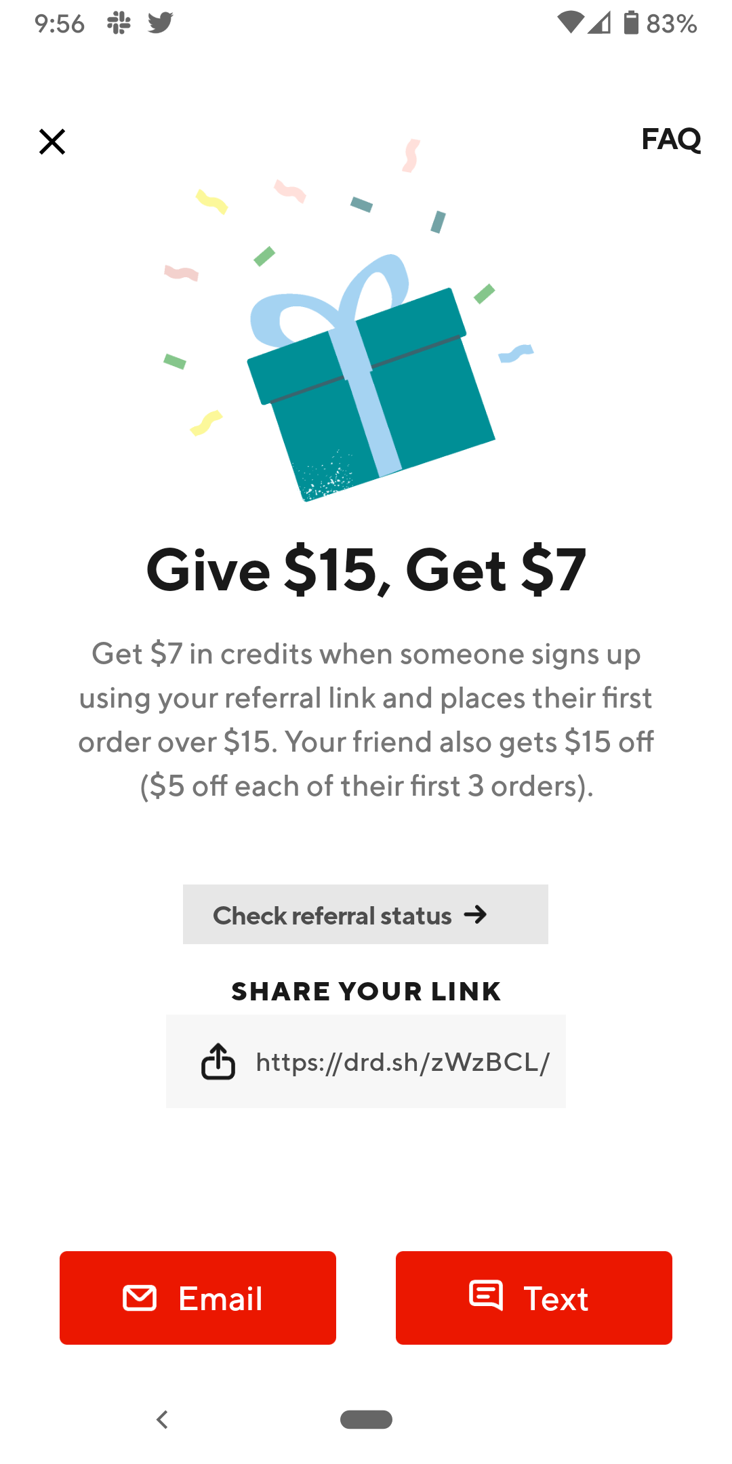
    - 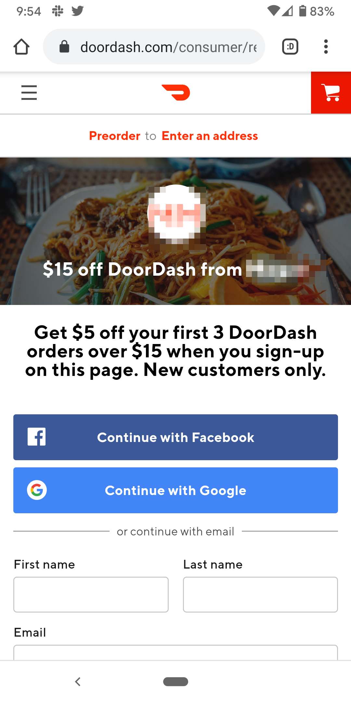
    - 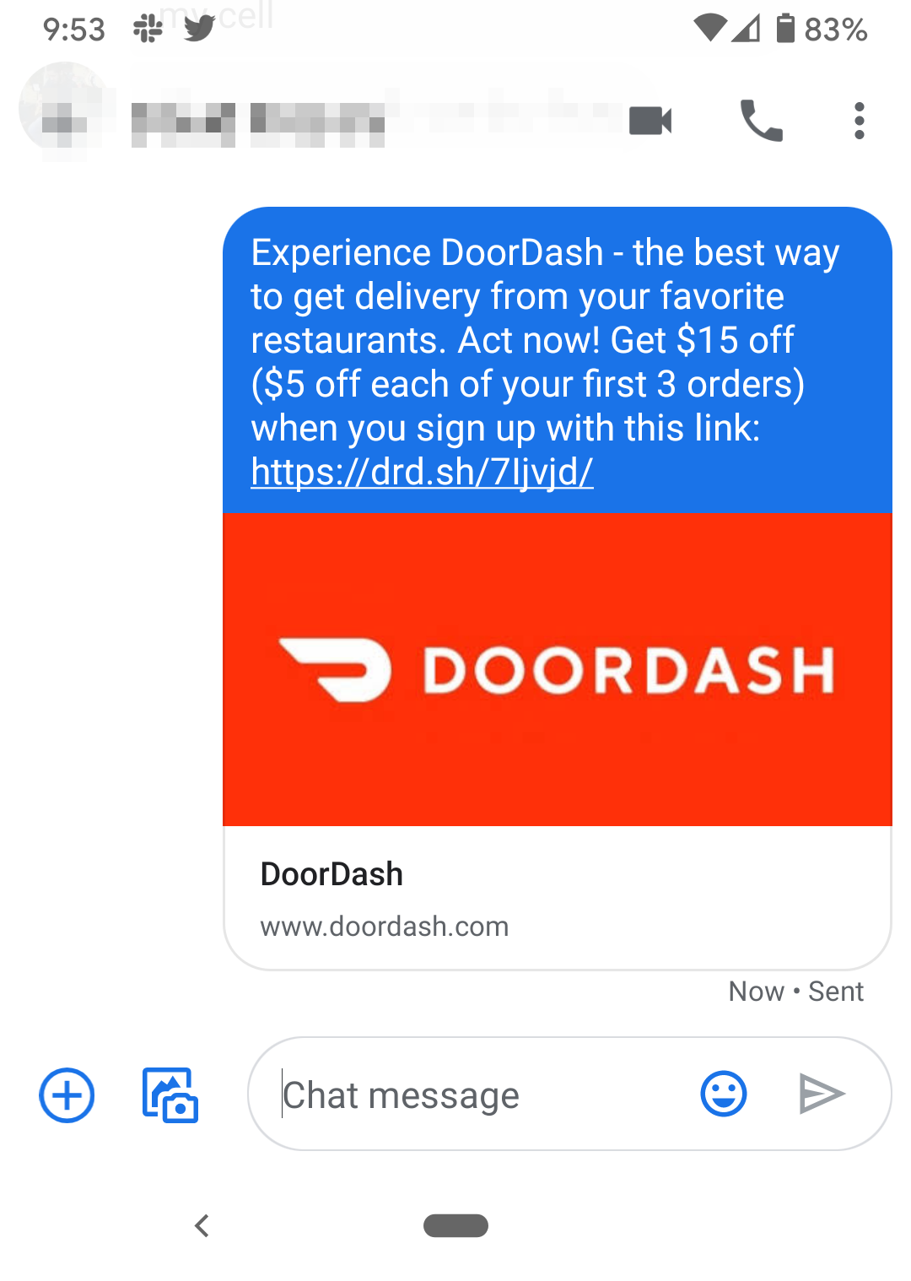
- Instagram:
  - Filters
  - Video Posts
  - Instagram Stories
  - Stories Highlights
    - Alexa Amundson intro first
    - Properties
    - Newsletter
    - New Development
    - Renovations
    - Culture
    - The economy
  - Instagram Stories video
  - AR Filters
  - IGTV
  - Stickers
  - Quizzes
  - Hashtags
  - Profile Photo
  - Bio
  - Shorts

- Twitter:
  - Branded Hashtag
  - Profile Photo
  - Header
  - Bio - 160 characters
  - Lists
  - Twitter VIT
  - Conversational
  - Hashtags - raise awareness
  - Twitter SMS?
  - Trending Topics
  - Moments
  - Verified
  - Polls
  - Legacy Twitter archive format
  - Spaces
  - Twitter Blue
  - Tip Jar
  - NFTs
  - Live Shopping
  - Gifs

- Facebook
  - Events
  - Marketplace
  - Places
  - Pages
  - Photo Albums
  - Filters
  - Videos
  - 360-degree videos
  - Live Streaming
  - Closed Captioning
  - Facebook Paper
  - Facebook Mentions
  - Facebook Moments
  - Facebook Gaming
  - Facebook Podcasts
  - Groups
  - Articles
  - Hashtags
  - Donate

- Tik Tok
  - Paid Video Advertisement
  - Duets
  - Genres
    - like pranks, stunts, tricks, jokes, dance, and entertainment
  - Creative Techniques
  - Account Video Content

- YouTube
  - Shorts
  - Paid Advertisements
  - Account Video Content

- LinkedIn
  - Skill Assessments
  - Resume
  - Create a Poll
  - Find an Expert
  - Add a document
  - Celebrate an occasion
    - Give Kudos
    - Welcome to the Team
    - Project Launch
    - Work Anniversary
    - New Position
    - Create Event
      - LinkedIn Live
      - External Event link
  - Prepare for an interview
  - Share Post
  - Comment on Post
  - Reactions (like)
    - Thumbs up
    - Clap
    - Give a heart?
    - Heart
    - Lightbulb
    - Thinking
  - Take a video
  - Add a photo

- Reddit:
  - create an account

- Website:
  - Home page

- All Sites
- Analytics

- ****A calendar can also help you assess your content and see if you’re sharing a balanced mix of tweets. You want to follow the rule of thirds (number 8 on this list): ⅓ of tweets promote your business, ⅓ share personal stories, and ⅓ are informative insights from experts or influencers.

Sunday | Monday | Tuesday | Wednesday | Thursday | Friday | Saturday
 |  | ¹  ^{Interaction Day!} | ²  ^{Info Day!} | ³  ^{Interaction Day!} | ⁴  ^{Brand Day!} | ⁵
⁶ | ⁷  ^{Personal Day!}  ^{Goodwill Day} | ⁸  ^{Interaction Day!} | ⁹  ^{Info Day!} | ¹⁰  ^{Interaction Day!} | ¹¹  ^{Brand Day!} | ¹²
¹³ | ¹⁴  ^{Personal Day!} | ¹⁵  ^{Interaction Day!} | ¹⁶  ^{Info Day!} | ¹⁷  ^{Interaction Day!} | ¹⁸  ^{Brand Day!} | ¹⁹
²⁰ | ²¹  ^{Personal Day!} | ²²  ^{Interaction Day!} | ²³  ^{Info Day!} | ²⁴  ^{Interaction Day!} | ²⁵  ^{Brand Day!} | ²⁶
²⁷ | ²⁸  ^{Personal Day!} | ²⁹  ^{Interaction Day!} | ³⁰  ^{Info Day!} | ³¹  ^{Interaction Day!}
March goal:

Sunday | Monday | Tuesday | Wednesday | Thursday | Friday | Saturday
 |  |  |  |  | ¹  ^{Brand Day!} | ²
³ | ⁴ | ⁵ | ⁶  ^{Info Day!} | ⁷ | ⁸  ^{Brand Day!} | ⁹
¹⁰ | ¹¹ | ¹² | ¹³  ^{Info Day!} | ¹⁴ | ¹⁵  ^{Brand Day!} | ¹⁶
¹⁷ | ¹⁸ | ¹⁹ | ²⁰  ^{Info Day!} | ²¹ | ²²  ^{Brand Day!} | ²³
²⁴ | ²⁵ | ²⁶ | ²⁷  ^{Info Day!} | ²⁸ | ²⁹  ^{Brand Day!} | ³⁰

Sunday | Monday | Tuesday | Wednesday | Thursday | Friday | Saturday

Sunday | Monday | Tuesday | Wednesday | Thursday | Friday | Saturday

Sunday | Monday | Tuesday | Wednesday | Thursday | Friday | Saturday

Sunday | Monday | Tuesday | Wednesday | Thursday | Friday | Saturday

Sunday | Monday | Tuesday | Wednesday | Thursday | Friday | Saturday

Sunday | Monday | Tuesday | Wednesday | Thursday | Friday | Saturday

Sunday | Monday | Tuesday | Wednesday | Thursday | Friday | Saturday

Sunday | Monday | Tuesday | Wednesday | Thursday | Friday | Saturday

Sunday | Monday | Tuesday | Wednesday | Thursday | Friday | Saturday

Sunday | Monday | Tuesday | Wednesday | Thursday | Friday | Saturday

